LIBRARY HOME PAGE
http://library.sewanee.edu

REGULAR LIBRARY HOURS
- Monday–Thursday 7:30 a.m. – 1:00 a.m.
- Friday 7:30 a.m. – 10:00 p.m.
- Saturday 9:00 a.m. – 6:00 p.m.
- Sunday 11:00 a.m. – 1:00 a.m.

INTERIM HOURS
- Monday-Friday 8:00 a.m. – 5:00 p.m.
- Saturday CLOSED
- Sunday CLOSED

SUMER Advanced Degree Program HOURS
- Monday-Friday 8:00 a.m. – 10:00 p.m.
- Saturday 9:00 a.m. – 6:00 p.m
- Sunday 1:00 p.m. – 10:00 p.m

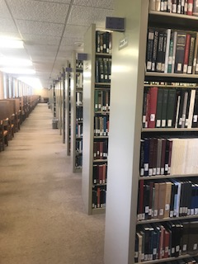

“THEOLOGY Stacks”
- Library of Congress classification system ranges B–BX;
- Located in the SE corner of the third floor of duPont Library
- Marked as Main Collection on the Library Catalogue
- All stacks’ materials can be checked out and renewed online or by phone, but need to be returned at Circulation/Drop off box on time to avoid fines.
- There is a self-checkout service machine located near the central elevator of the third floor; alternatively, for circulation assistance you can go to the Circulation Desk, located on the first floor of duPont, or call 931.598.1664.

THEOLOGY REFERENCE-duPont third floor
- These reference materials are labeled as Theology Ref. on the book spine
- They are designated to be used only in the immediate vicinity of the Theology Reference area
- Please, do not take reference books away, but return them to their original location or place them in the re-shelving area
- If an item is needed for a longer time, please, scan/photocopy the appropriate pages or find the stacks copy

THEOLOGY RESERVES-Hamilton Hall Reading Room
- There is a separate section for each SoT course
- No need to look up titles in the library catalog
- Please, sign up in the Reserves’ binder every time you use a reserve material
- Read books only in the Hamilton Reading Room and return books to proper section when finished

THEOLOGY PERIODICALS third floor
- arranged in Library of Congress classification order with current issues on display; back volumes following in order; red labels on end of ranges
- Diocesan Journals and Newsletters are arranged alphabetically by title
- Periodicals are to be used in the immediate area only, please, do not take them away
- when finished, please, set them in the re-shelving area

SCANNING and PHOTOCOPYING
- Convenient locations: 3rd floor & ground floor of duPont; Computer lab in Hamilton Hall
- Printing and scanning is momentarily free
- Scanning to a Google Drive, USB memory stick or e-mail is free and highly recommended

STUDY SPACES
- The 3rd floor of the Library is designated as a QUIET Study Area
- duPont 339 is our SoT Study Area (ask for key #12 @ Circulation) with 12 assignable desks
- In addition, we have 8 closed study carrels located around the Liturgy Room; these carrels can be assigned to individual students at the beginning of each term
- All open seating at library carrels and tables can be used
- Materials may be left on carrels and tables only if checked out to you
- Leave note on table with your name on it, so that materials will not be removed
- Personal items (e.g., computers, phones) are left at your own risk
- Room 330 and 331 can be reserved for group study

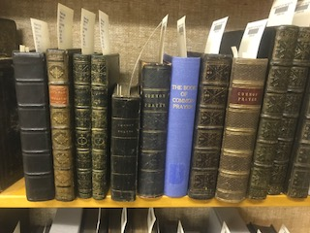

THEOLOGY SPECIAL COLLECTIONS
- Old Bibles and BCP’s can be consulted by appointment in the Liturgy Room (duPont 334)
- All the other Theology Special Collections are hosted in the University Archives and Special Collections; access is only by appointment (email: archives@sewanee.edu or phone (931.598.3212)

OTHER LIBRARY SERVICES
- Internet: wireless secure and guest access available on campus
- Public Computers: available for patrons on a first come first served basis; computer labs available for usage on the ground floor
- Accordance and Bibleworks software available on a couple designated duPont 3rd floor and Hamilton Computer Lab terminals
- Academic technology services and immediate troubleshooting help is available via HelpDesk located on the ground floor in DuPont (email: helpdesk@sewanee.edu Phone: (931)-598-1369
- Group study rooms available throughout the library; may be reserved through EMS: https://sewanee.emscloudservice.com/web/
- Inter Library Loan (Sewanee ILL) services (email: ils@sewanee.edu Phone: (931)-598-1697)
- Fooshee collection (popular fiction, children literature, newspapers, movies, audio books collection) available on the 1st floor of duPont
- 7 days/week, 24 hours/day study space available on the ground floor of duPont Library

OFFSITE USE OF ELECTRONIC RESOURCES
Some databases may require your Banner user name and password when connecting to them off-campus. Please, use your user credentials via your Sewanee proxy connection.

Should you have any questions or concerns, please, feel free to raise them.
We are glad to have you here!

